**Compte rendu TP 6 :**

Administration de bases de données

**Travail réalisé conjointement par :**

Mohamed Aziz Bellaaj

Louay Badri

Salma Ghabri

Safa Weslati

**Groupe:** GL 4/2

1) Open SQL Server Profiler and use the template TSQL_Duration to monitor when T-SQL statements have been completed.

2) Run the following query in SSMS.

1. USE AdventureWorksDW2014

2. go

3. select count(*) from [dbo].[DimDate]

3) Go back to SQL Server Profiler and see what the results are.

At first query run after server start:

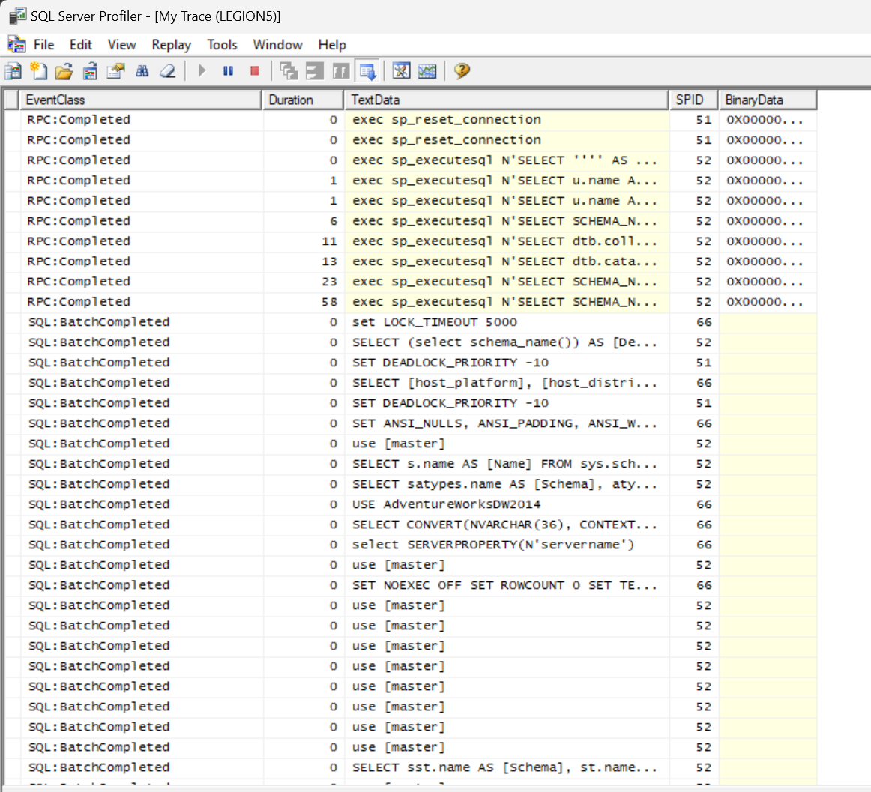

Later:

4) Do the same thing in Extended Events. Make sure you select/check the following checkboxes: “Start the event session immediately after session creation”, and “Watch live data on screen as it is captured.”

5) Open Performance Monitor and monitor the “% Processor Time” (the default). Add to this, in the Processor category, “% Privileged Time”.

